E-Commerce Product Entity Resolution and Matching Platform

Project Report submitted for the partial fulfilment of grade for the course

Data Structures and Algorithms -3 (25CS2103E)
in

A.Y. 2026-2027

Submitted by
Shreyas Panjala (2520080001)

Team Number: 33
Section: 12

Under the guidance of

Ms. K Chandusha
Assistant Professor,

Department of Computer Science and Information Technology
Hyderabad-500090, Telangana, India.

K L (Deemed to be) University
DEPARTMENT OF COMPUTER SCIENCE AND INFORMATION TECHNOLOGY/ARTIFICIAL INTELLIGENCE & DATA SCIENCE



DECLARATION

The Mini Project Report entitled “E-Commerce Product Entity Resolution and Matching Platform” is a record of Bonafide work of Shreyas Panjala – 2520080001 submitted in partial fulfillment for the award of B. Tech in Artificial Intelligence & Data Science to the K L (Deemed to be) University. The work presented in this report focuses on the application of data structures and algorithms to the problem of resolving and matching e-commerce product entities. The results embodied in this report have been prepared for academic submission.

Shreyas Panjala – 2520080001

K L (Deemed to be) University
DEPARTMENT OF COMPUTER SCIENCE AND INFORMATION TECHNOLOGY/ARTIFICIAL INTELLIGENCE AND DATA SCIENCE
CERTIFICATE

This is to certify that the mini project based report entitled “E-Commerce Product Entity Resolution and Matching Platform” is a bonafide work done and submitted by Shreyas Panjala – 2520080001 in partial fulfillment of the requirements for the award of the degree of BACHELOR OF TECHNOLOGY in Artificial Intelligence & Data Science, K L (Deemed to be) University, during the academic year 2026-2027.

Signature of the Supervisor

Signature of the HOD Signature of the External Examiner

ACKNOWLEDGEMENT

The success in this project would not have been possible without the timely help and guidance rendered by many people. I express my sincere thanks to all those who assisted me directly or indirectly in completing this project.

My greatest appreciation goes to my guide, Ms. K Chandusha, Assistant Professor, Department of Computer Science and Information Technology, for her valuable guidance, encouragement, technical suggestions, and continuous support throughout the project.

I express my gratitude to the Head of the Department and the faculty members of the Department of Artificial Intelligence & Data Science (Dr. Srinath Itikela) and the Head of the Department of Computer Science and Information Technology (Dr. Khaja Shareef) for providing the facilities and academic environment required to complete this project. I also thank the teaching and non-teaching staff members who assisted me during the work.

Finally, I sincerely thank my parents, friends, and classmates for their cooperation, encouragement, and support throughout the completion of this project.

Shreyas Panjala – 2520080001

TABLE OF CONTENTS

S.No. | Contents | Page No
1. | Abstract | 6
2. | Introduction | 7
3. | Literature survey | 8
4. | Problem Statement and Objectives | 10
5. | Hardware and Software requirements | 11
6. | Implementation | 12
7. | Results & Discussion | 15
8. | Conclusion & Future Scope | 16
9. | References | 18

1.ABSTRACT

The E-Commerce Product Entity-Resolution and Matching Platform aims to identify and group identical products listed by different sellers under varying names, descriptions, and specifications into a unified product catalog. This enables accurate product search, duplicate detection, price comparison, and better decision-making for customers. The project analyzes the product-matching problem and selects algorithmic strategies based on input characteristics. Knuth-Morris-Pratt (KMP) and Rabin-Karp algorithms are used for efficient pattern matching and duplicate title detection, while Suffix Arrays support similarity analysis between product descriptions. The Wagner-Fischer Edit Distance algorithm, based on Dynamic Programming, handles spelling variations and incomplete product names. A bipartite graph represents seller-product relationships, and the Edmonds-Karp Maximum Flow algorithm assigns listings to canonical products. A greedy approximation algorithm is applied to obtain near-optimal solutions for large datasets. Randomized hashing accelerates duplicate detection, while parallel processing improves scalability when handling thousands of product listings simultaneously. The proposed system provides an efficient, scalable, and accurate application of advanced data structure concepts in a real-world e-commerce environment.
Team Name: E-Commerce Product Entity Resolution and Matching Platform

Team Logo (if any): Not applicable.

Team Members:
1. Shreyas Panjala – 2520080001

- INTRODUCTION

E-commerce platforms contain multiple listings for the same real-world product because different sellers use different product names, descriptions, spellings, and specifications. If these listings are not resolved to a common identity, product catalogs can contain duplicates and customers may have difficulty with search, comparison, and purchasing decisions.
The E-Commerce Product Entity-Resolution and Matching Platform addresses this problem by applying multiple data structures and algorithms to identify and group identical product listings. KMP and Rabin-Karp support title matching and duplicate detection, Suffix Arrays support similarity analysis of product descriptions, and Wagner-Fischer Edit Distance handles spelling variations and incomplete product names. A bipartite graph models seller-product relationships, while Edmonds-Karp Maximum Flow assigns listings to canonical products.
Greedy approximation, randomized hashing, and parallel processing are incorporated to reduce computational cost and improve scalability for large numbers of product listings. The report presents the problem, related work, objectives, requirements, implementation modules, results, conclusion, and references.

3.LITERATURE SURVEY
1. Tailoring Entity Resolution for Matching Product Offers – Köpcke et al. studied product matching as a specialized entity-resolution problem and addressed the difficulty of heterogeneous product offers using preprocessing and extracted product attributes. The work is directly relevant to the proposed platform because both systems focus on identifying offers that refer to the same product.
2. E-Commerce Product Matching at Internet Scale – Sortur et al. presented a large-scale product-matching system for e-commerce, focusing on product deduplication, competitive pricing, and grouping offers. The work demonstrates the importance of efficient matching when millions of product offers must be associated with catalog products.
3. Scalable Entity Resolution for Web Product Descriptions – Vandic et al. investigated scalable entity resolution for web product descriptions and evaluated blocking strategies on real-world datasets. The study highlights the importance of reducing the number of comparisons while maintaining effective product matching.
4. The WDC Training Dataset and Gold Standard for Large-Scale Product Matching – Primpeli, Peeters, and Bizer introduced training and evaluation resources for large-scale product matching. The work provides a useful basis for evaluating approaches that resolve product records collected from different web sources.
5. Towards Multi-modal Entity Resolution for Product Matching – Wilke and Rahm extended product matching beyond textual and numerical attributes by incorporating product images. Their findings show that additional modalities can improve recall when textual information alone is insufficient.
6. An Entity-Matching System Based on Multimodal Data for E-Commerce Stores – This work developed a multimodal entity-matching system for product comparison using textual and image information. It demonstrates how entity matching can support price comparison and consolidation of product information across online stores.
7. Cost-Efficient Prompt Engineering for Unsupervised Entity Resolution in the Product Matching Domain – Nananukul, Sisaengsuwanchai, and Kejriwal examined entity resolution for product matching and explored methods for reducing the cost of obtaining effective matching decisions. The study reinforces the importance of scalable product matching for heterogeneous e-commerce data.
8. Unified AI Approach for Variant Product Matching in E-Commerce – Herrero-Vidal et al. investigated variant-product relationships in e-commerce catalogs. The work distinguishes exact entity resolution from related-product and variant relationships, showing the broader importance of understanding relationships among catalog products.

4.Problem Statement and Objectives

Problem Statement: E-commerce platforms contain duplicate or equivalent product listings that use different names, descriptions, spellings, and specifications, making reliable product identification and comparison difficult.
Problem Description: The system must identify relationships among heterogeneous seller listings and assign matching listings to canonical products efficiently, while supporting large numbers of product records.

Objectives:
Project Purpose:
The project demonstrates DSA-based entity resolution by detecting duplicates, grouping equivalent listings, creating consistent product identities, and supporting reliable product search and comparison.

4.HARDWARE AND SOFTWARE REQUIREMENTS
Hardware Requirements:
- Computer or laptop with a multi-core processor for algorithm execution and parallel processing.
- Minimum 4 GB RAM, with additional memory for larger product datasets.
- Adequate local storage for product records and intermediate processing data.
Software Requirements:
- Development environment capable of implementing string, dynamic-programming, graph, hashing, and parallel-processing algorithms.
- Operating system supporting the chosen development environment and project execution.
- Web browser for accessing the product matching platform and viewing results.
- Data-processing utilities for reading, organizing, comparing, and managing seller product listings.

5.IMPLEMENTATION
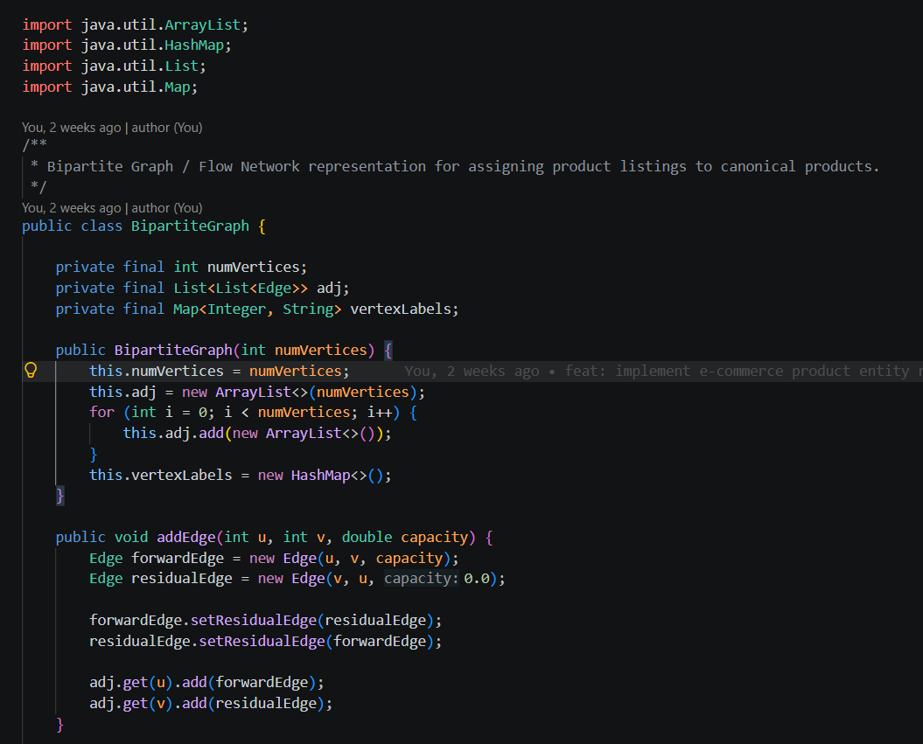

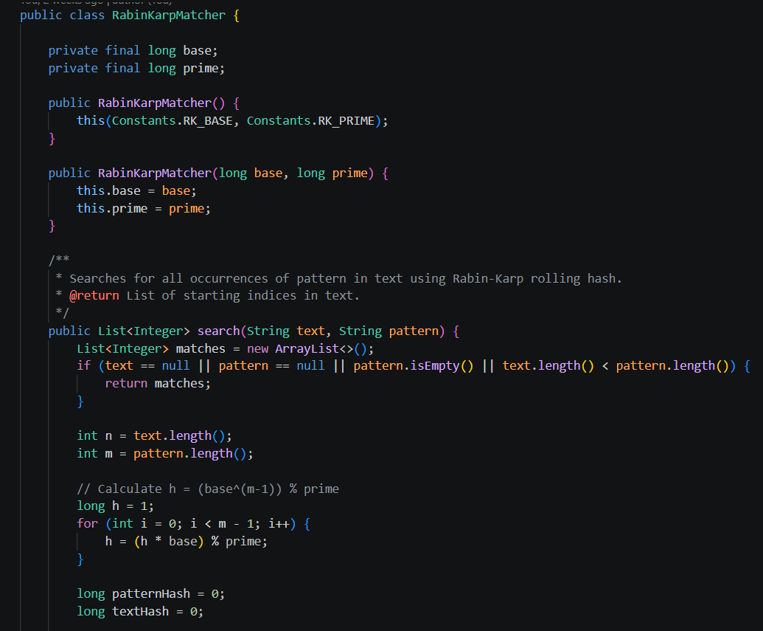

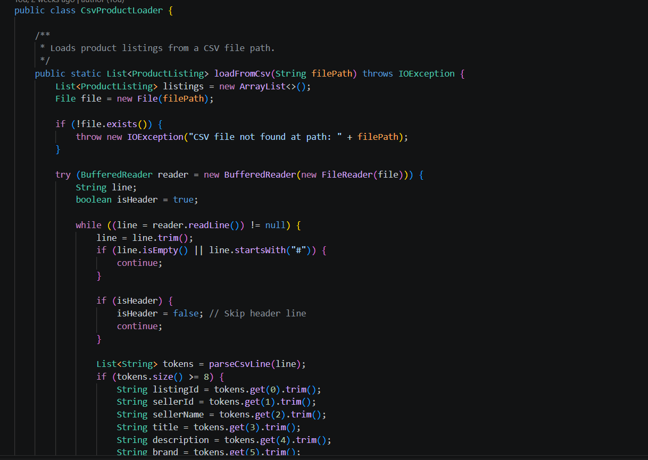
RESULTS & DISCUSSION


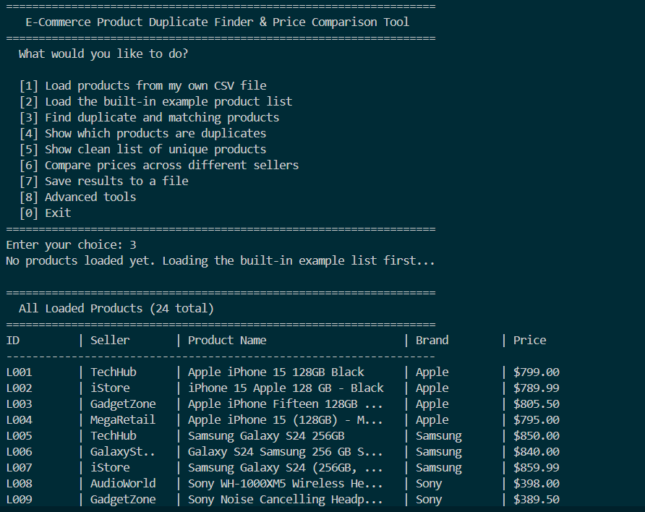
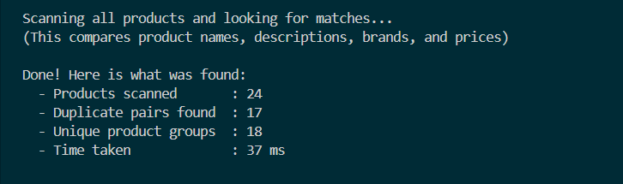

7.CONCLUSION & FUTURE SCOPE
The Product Entity Resolution & Matching Platform was developed to address the problem of duplicate and inconsistent product listings across multiple e-commerce sellers. The project successfully implements an end-to-end entity resolution pipeline that processes product data, normalizes product descriptions, identifies potential matches, calculates similarity scores, and groups matching listings into a unified canonical product catalog.
The primary objectives were addressed through the implementation of fundamental data structures and algorithms, including Knuth-Morris-Pratt (KMP), Rabin-Karp, suffix arrays, Levenshtein edit distance using dynamic programming, randomized hashing, greedy matching, graph-based maximum flow, and parallel processing. The platform also supports CSV data import, matched-product inspection, canonical catalog generation, cross-seller price comparison, and report export through a command-line interface.
The project demonstrates how the integration of multiple algorithmic techniques can improve the organization and analysis of product listings while reducing unnecessary pairwise comparisons through candidate blocking. Overall, the implementation provides a functional foundation for e-commerce product entity resolution and demonstrates the practical application of data structures and algorithms to a real-world catalog management problem. It also highlights the importance of balancing matching accuracy, computational efficiency, and scalability when processing large and diverse product datasets.

Future Scope
The Product Entity Resolution & Matching Platform can be enhanced in the following ways:
- Near-Term: Improve similarity scoring, input validation, and matching accuracy through extensive testing.
- Medium-Term: Integrate machine learning for product matching, database storage, and a web-based user interface.
- Long-Term: Implement distributed processing, semantic matching using language models, and automated catalog updates to support large-scale e-commerce platforms.
These enhancements can improve the platform’s accuracy, scalability, efficiency, and practical applicability in real-world product catalog management.

8 .REFERENCES

1. Köpcke, H., Thor, A., Thomas, S., & Rahm, E. (2012). Tailoring entity resolution for matching product offers. https://doi.org/10.1145/2247596.2247662
2. Sortur, M., Rajpoot, P., Manjunath, S., Subhanandh, T., & Rao, H. C. (2022). E-Commerce Product Matching at Internet Scale. https://doi.org/10.1145/3556089.3556149
3. Vandic, D., Frasincar, F., Kaymak, U., & Riezebos, M. (2020). Scalable entity resolution for Web product descriptions. Information Fusion, 53, 103–111. https://doi.org/10.1016/j.inffus.2019.06.001
4. Primpeli, A., Peeters, R., & Bizer, C. (2019). The WDC Training Dataset and Gold Standard for Large-Scale Product Matching. https://doi.org/10.1145/3308560.3316609
5. Wilke, M., & Rahm, E. (2021). Towards Multi-modal Entity Resolution for Product Matching. https://dbs.uni-leipzig.de/research/publications
6. Nananukul, N., Sisaengsuwanchai, K., & Kejriwal, M. (2024). Cost-efficient prompt engineering for unsupervised entity resolution in product matching. https://doi.org/10.1007/s44163-024-00159-8
7. Ruan, Q., Shi, D., & Bauernhansl, T. (2025). Fine-tuning large language models for selective entity matching in product data integration. https://doi.org/10.1016/j.aei.2025.103538
8. Herrero-Vidal, P., Chen, Y.-L., Liu, C., Xu, B., Sen, P., & Wang, L. (2026). Unified AI approach for variant product matching in e-commerce. https://doi.org/10.1177/2167647X261423127
9. An entity-matching system based on multimodal data for two major e-commerce stores in Mexico. Mathematics, 10(15), 2564 (2022). https://doi.org/10.3390/math10152564
10. An evaluation and annotation methodology for product category matching in e-commerce. Computers in Industry, 131, 103497 (2021). https://doi.org/10.1016/j.compind.2021.103497

